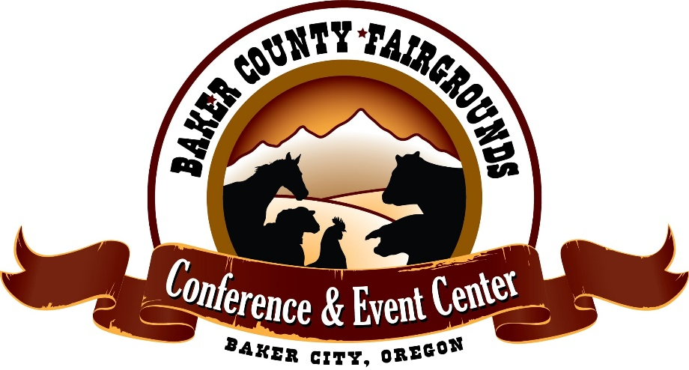
Pee-Wee Showmanship
Open Class for youth too young to compete in 4-H

Show time: Thursday, August 10th at 4:30pm

Rules:
This is an open class show, meaning it is open to any youth from anywhere.
It is intended for fun and not competition.
It is only for the “pee-wee” youth!
If at any time safety is at risk the management will intervene.
Entry forms will also be available the day of the show in the Cockram Arena until 12:00pm.
Entry forms must be received by 12:00pm the day of the show.
Limited to 50 entries (No added entries unless approved)

Age Divisions: Pee-Wee......................... Kindergarten and under
Half-Pint.........................1st and 2nd grade
Short Stuff......................3rd grade (not old enough to participate in 4-H)

Animals used will be pre-arranged the superintendant before the show.
All entries must read, agree, and abide to all rules for this show and the general rules of the Baker County Fair. Violators will not be allowed to complete the show and may be asked to leave the grounds.
All entries must sign a waiver of liability/official entry form before show.
Entry forms will also be available on the bulletin board in the Cockram Arena until 12:00pm the day of the show.
Prizes will be awarded only, no premiums will be paid.

We hereby release the Baker County Fair, Fair Board, Staff, Directors, and all volunteers involved from all liabilities of any kind or character for loss, damage, or injury to exhibitor, animal or personal property. We agree as the Parent/Guardian and Pee-Wee Exhibitor to abide by all the rules as listed above and in the general rules section of the Baker County Fair Book for the said contest.

_____________________________________________ _____________________________
Name of Parent/Guardian (Please print clearly) Cell Phone Number

_____________________________________________ ___________________
Signature of Parent/Guardian Date

_____________________________________________ ___________________
Name of Child Exhibiting (Please print clearly) Age of Child Exhibiting

_____________________________________________ ______________________________________
Type of Animal requested (lamb, swine, or goat) Age Division (Pee-Wee, Half-Pint, Short Stuff)

